**Bootstrap navigation menu in asp.net core application**

**creating a responsive navigation menu in asp.net core application using Bootstrap 4**.  
  
  
On a large screen device the navigation menu should look as shown below.  
  
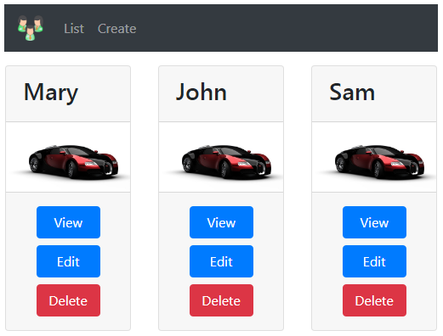  
  
  
On a small screen device the navigation menu should look as shown below.  
  
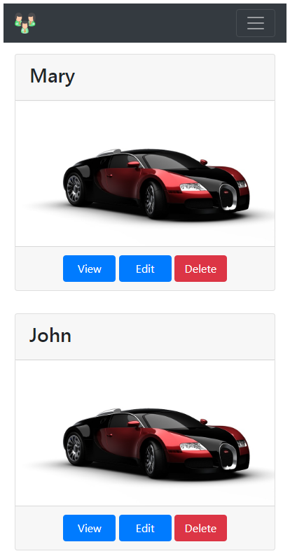  
  
**Bootstarp 4 has a dependency on jQuery.** So please download and install jQuery in your asp.net core application. You can use the Library Manager tool to do this.

**_Layout.cshtml Code**

<html>

<head>

    <meta name="viewport" content="width=device-width" />

    <**environment** **include**="Development">

        <link href="~/lib/bootstrap/css/bootstrap.css" rel="stylesheet" />

        <script src="~/lib/jquery/jquery.js"></script>

        <script src="~/lib/bootstrap/js/bootstrap.js"></script>

    </**environment**>

    <**environment** **exclude**="Development">

        <**link** rel="stylesheet" **href**="https://stackpath.bootstrapcdn.com/bootstrap/4.3.1/css/bootstrap.min.css"

              integrity="sha384-ggOyR0iXCbMQv3Xipma34MD+dH/1fQ784/j6cY/iJTQUOhcWr7x9JvoRxT2MZw1T" crossorigin="anonymous"

**asp-fallback-href**="~/lib/bootstrap/css/bootstrap.min.css"

**asp-fallback-test-class**="sr-only" **asp-fallback-test-property**="position" **asp-fallback-test-value**="absolute"

**asp-suppress-fallback-integrity**="true" />

    </**environment**>

    <link href="~/css/site.css" rel="stylesheet" />

    <title>@ViewBag.Title</title>

</head>

<body>

    <div class="container">

        <nav class="navbar navbar-expand-sm bg-dark navbar-dark">

            <**a** class="navbar-brand" **asp-controller**="home" **asp-action**="index">

                <img src="~/images/employees.png" width="30" height="30">

            </**a**>

            <button class="navbar-toggler" type="button" data-toggle="collapse" data-target="#collapsibleNavbar">

                <span class="navbar-toggler-icon"></span>

            </button>

            <div class="collapse navbar-collapse" id="collapsibleNavbar">

                <ul class="navbar-nav">

                    <li class="nav-item">

                        <**a** class="nav-link" **asp-controller**="home" **asp-action**="index">List</**a**>

                    </li>

                    <li class="nav-item">

                        <**a** class="nav-link" **asp-controller**="home" **asp-action**="create">Create</**a**>

                    </li>

                </ul>

            </div>

        </nav>

        <div>

            @RenderBody()

        </div>

        @if (IsSectionDefined("Scripts"))

        {

        @RenderSection("Scripts", required: false)

        }

    </div>

</body>

</html>

On a small screen device, for the ***navbar***toggle button to work, jQuery must be loaded before Bootstrap JavaScript file. If you flip the order, the ***navbar toggle button***does not work.

<**environment** **include**="Development">

    <link href="~/lib/bootstrap/css/bootstrap.css" rel="stylesheet" />

    <script src="~/lib/jquery/jquery.js"></script>

    <script src="~/lib/bootstrap/js/bootstrap.js"></script>

</**environment**>

**Please note :**For a ***non-development environment***(i.e Staging, Production etc), I have not included the required <link> tags to load jQuery and Bootstrap JavaScript from a CDN. I am leaving that as an exercise for you to do.  
  
Notice how the buttons ***(View, Edit & Delete)*** are attached to each other. To include margin between these button use the Bootstrap margin classes ***(m-1, m-2 etc)***. In the class name, ***"m"*** stands for ***margin***and the number ***1,2 etc***is the size of the space you want.  
  
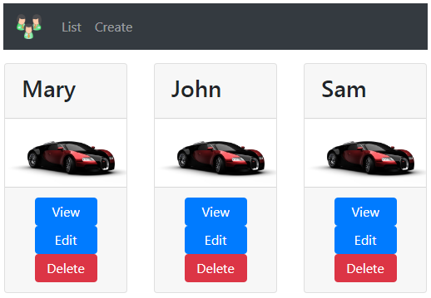  
  
In ***index.chtml*** modify the ***<a>*** tags to include ***"m-1"*** bootstrap class

<div class="card-footer text-center">

    <**a** **asp-controller**="home" **asp-action**="details"

**asp-route-id**="@employee.Id" class="btn btn-primary m-1">View</**a**>

    <a href="#" class="btn btn-primary m-1">Edit</a>

    <a href="#" class="btn btn-danger m-1">Delete</a>

</div>